Exodus:
God Rescues the Israelites
Exodus 12:1-42; 14:5-31
Through the Week
- Look up the following verses with your family. Write them on sticky notes or index cards.
  - Romans 8:28
  - Proverbs 3:5-6
  - Jeremiah 29:11
  - Philippians 4:6
  - Psalm 46:1
  - Joshua 1:9
- You could also find other verses that remind you to trust God’s plan.
- If your child made the “Reminder Sheep” craft, you can add the cards from that craft as well.
- Hang the notes around a door frame you’ll all walk through often—your front door or a bathroom door, for example.
- Whenever you walk through that door, remember how God did what was best for the Israelites when he kept them safe and how God wants what’s best for you.

Talk About This…
- Tell about a time God did something great for you.
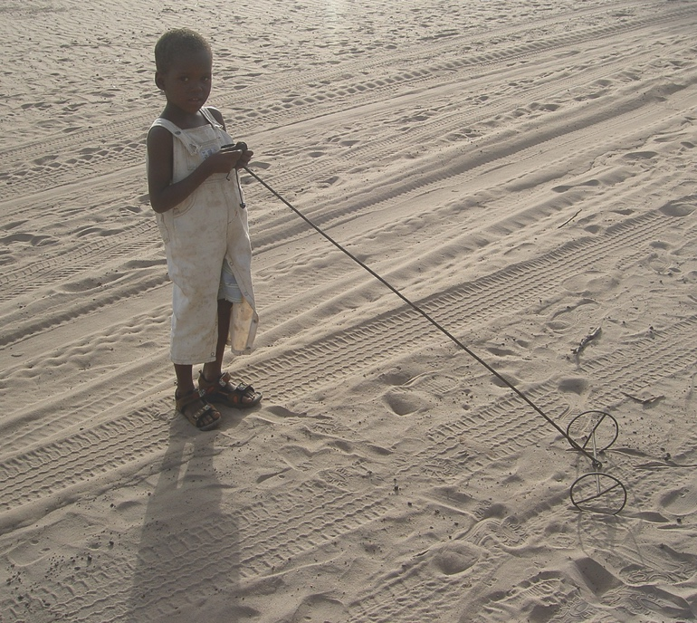
Church Announcements
- Don’t Forget About Our Easter Egg Hunt!
- Saturday March 31st at the Pavilion in Molena
- Starts @

“And we know that God causes everything to work together for the good of those who love God and are called according to his purpose for them” (Romans 8:28).
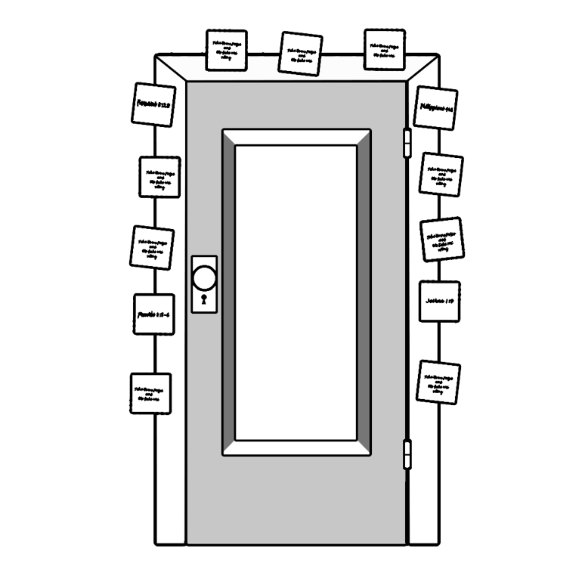
God sends a final plague so Pharaoh will let the Israelites escape. God kills all the firstborn sons, passing over homes with lambs’ blood on the door frames. The Israelites escape, but the Red Sea is in their way. God parts the Red Sea. God wants what’s best for us.

